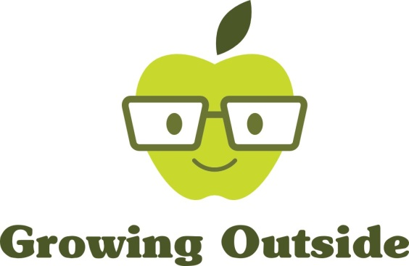
Cadishead Primary School

Thursday 27th September 2018
Weather: warm and sunny

Group: Year 1
Winter Vegetables

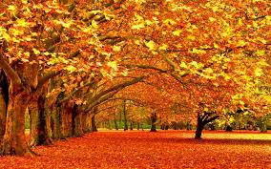
This week, year 1 were sowing some vegetables to get a head start for next year.

First of all, the children agreed that we are now in Autumn. They knew this because some leaves are turning brown and falling off the trees, there are lots of conkers on the ground and the squirrels are busy burying nuts for winter time.

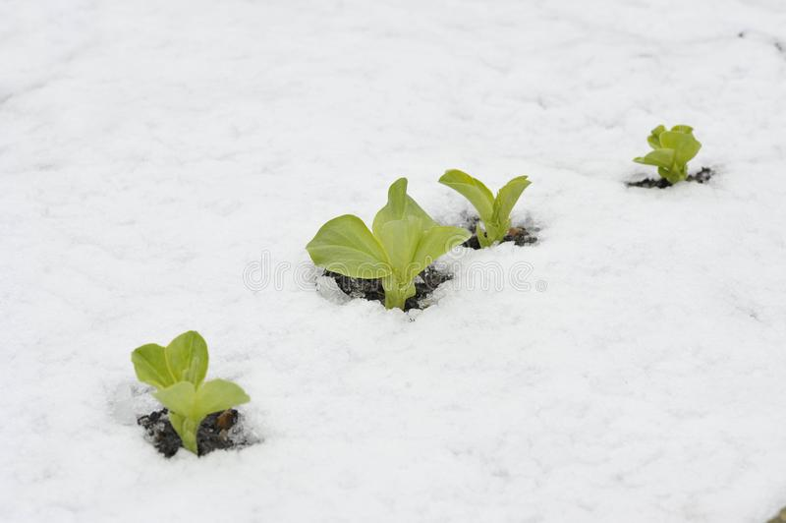
There are lots of seeds that don’t like to be planted in Autumn because they would not survive the cold winter. But luckily, there are some that don’t mind being planted now and won’t die when winter comes. Planting vegetables now means that they will be ready much earlier next year.

The vegetables Year 1 planted were broad beans, onions and garlic. We took a survey on how many children had ever tried these vegetables. Most of Year 1 had tried them but not everyone liked them!

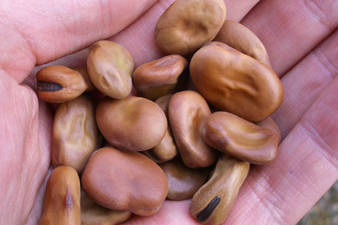
First we had a look as the bean seeds. We noticed that they were quite big, hard, smooth and brown. The children knew that to grow, the bean seeds would need soil, sun and water. So we chose a patch of soil in the vegetable patch and made holes to put our beans in. We pushed the beans down, covered them up with soil and after that we gave them a water. We wrote a label so that we would remember what we had sown there.
The children made guesses as to how long it would take before the beans would be ready to eat. One child correctly guessed that it could take up to 100 days before they would be ready!

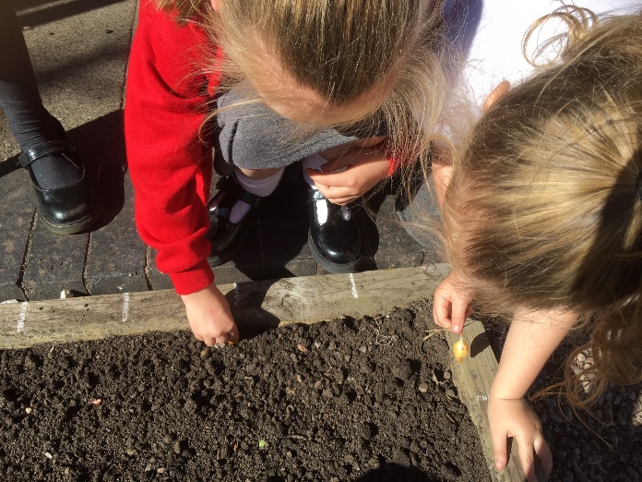
Next we planted onions in the exact same way as the beans. You can grow onions from seed, but we planted onion sets which are just very small onions. They will be ready much quicker this way. The children noticed that they were also brown and smooth but not as hard as the beans. They also smelt like cheese and onion crisps! Everyone guessed correctly which way round the sets had to be planted. Pointy bit pointing towards the sky!

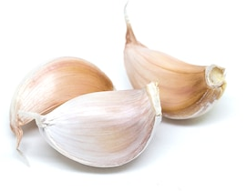

After that we planted garlic. Again, we planted garlic cloves instead of seeds. The garlic was curved like a banana, had white papery skin and smelt like garlic bread!
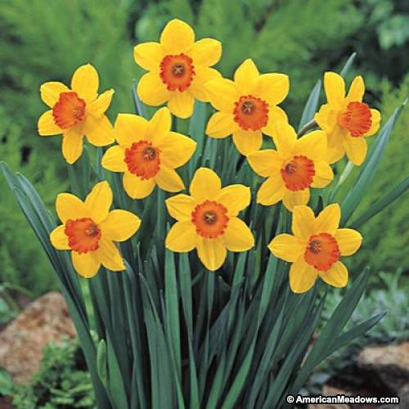
Last of all we planted daffodil bulbs. We can’t eat daffodils but they give us pretty flowers in spring. We had to take them out of the ground to make room for our vegetables so we planted them in pots instead.
Now all we have to do is be patient and wait for everything to grow!
Great work Year 1!
See you soon,
Catherine

